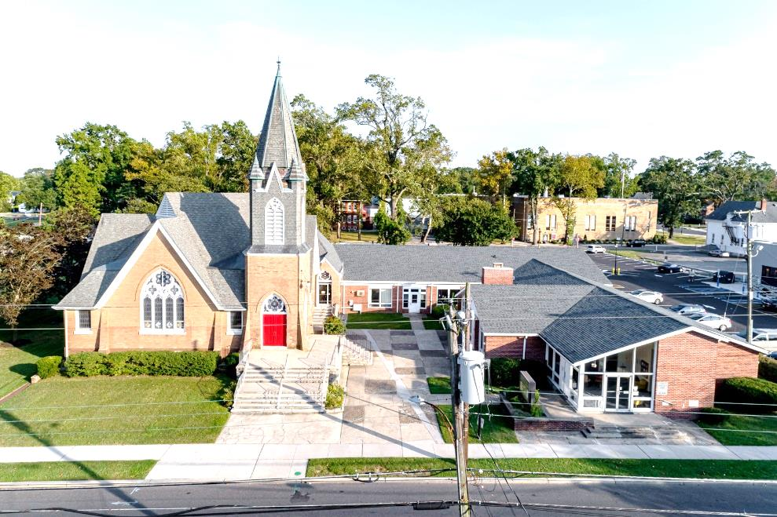

***The Presbyterian Church at Hammonton***



**Our vision is to open our doors to all seeking a spiritual home of worship and to carry the light and love of Jesus Christ, our Savior, throughout the community.**

**MISSION STATEMENT**

**We are committed to Jesus Christ and the growing of his Church by glorifying God and by proclaiming the *good news* of the gospel through word and deed. We involve and reach out to our members and our community in Christ’s name through worship, Christian Education, and stewardship to support the mission of our church.**

**Note: Special thanks to Rev. John Nurnberger for leading us in worship today.**

**Organist: Cindy Birnbaum**

**Sunday School Superintendent: Beth Burkett-Rice**

**2022 2023 2024**

**ELDERS**

**Eric Copenhaver Robert Bauers Sallye Hershman**

**Marylee Kondrach Dorrine Esposito Paul Moul**

**Charles Muller Richard Walker Johanna Johnson**

**DEACONS**

**Elsie Bakley Wendy Copenhaver Hilda Lugo**

**Nancy Foster Ann DiMeo Carol Orsi**

**Margaret Jones Rebecca Lindstrom Rebecca Villani**

**Clerk of Session: Beth Burkett-Rice**

**Church Office: 326 Bellevue Avenue, Hammonton, NJ**

**Office hours: *Tuesday - Thursday* 9:30 AM to 12:30 PM**

**Phone (609) 561-0168 ~ Fax (609) 561-6105**

**e-mail:** [**office@hammontonpres.org**](mailto:office@hammontonpres.org)

**website:** [**www.hammontonpres.org**](http://www.hammontonpres.org)

**THE CELEBRATION OF WORSHIP**

**MARCH 20TH, 2022**

**3RD SUNDAY IN LENT**

**VIRTUAL & LIVE SERVICE**

**11:00am**

**\*\*\*\*\*\*\*\*\*\*\*\*\*\*\*\*\*\*\*\*\*\*\*\*\*\*\*\*\*\*\*\*\*\*\*\*\*\*\*\*\*\*\*\*\*\*\*\*\*\*\*\***

***~ GATHERING IN GOD’S NAME ~***

*“Welcome to the Presbyterian Church at Hammonton, we are glad you are able to join us. As we gather for worship feel free to pray and meditate on God’s calling in your life. Be respectful of others around you who might be doing the same, prior and during the Prelude, keeping your voice and conversation soft and to a minimum.”*

**PRELUDE** *~“Quiet Prelude #1”-G. Martin*

*“The Path of Loving Kindness” -M. Shea*

*“Give Me Jesus”- L. Smith*

**~ TIME FOR CENTERING STILLNESS AND SILENCE ~**

**WELCOME AND ANNOUNCEMENTS**

**\*THE PEACE**

Let the people greet one another by **staying in their seats** and saying: “**Peace be with you!”**

**INTROIT**

***~ HUMBLY APPROACHING GOD ~***

**OPENING PRAYER**

**\*CALL TO WORSHIP**

**All: O God, I long for you, my soul thirsts for you;**

**all that is within me thirsts, as in a dry and barren land**

One: This is a place for those who are thirsty in spirit, to let God satisfy their souls.

**All: So here I am in this place, drinking in God’s glory and strength, God’s love and grace.**

One: Here in this oasis, drink freely from the deep well of Living Water; drink, and be renewed and refreshed.

**\*HYMN~** *“God, You Call Us to the Waters”(vv. 1&2)*

***God, You Call Us to the Waters***

*("Infant Holy, Infant Lowly")*

*God, you call us to the waters  
Where your gracious blessings flow,  
Yet we ask: "What should we offer?"  
"What's the cost?" We want to know.  
What we long for — can we earn it?  
Can we buy it? Can we learn it?  
What's the cost? We want to know.*

*We confess your invitation  
Sounds too wondrous to be true.  
Milk and wine and your salvation,  
Living water — gifts from you!  
May your waters and your table  
Now remind us you are able  
To give life, and life anew.*

[Tune: Polish melody ("Infant Holy, Infant Lowly")  Text: Copyright © 2016 by Carolyn Winfrey Gillette. All rights reserved. Used by permission]

**CALL TO CONFESSION**

**PRAYER OF CONFESSION (unison)**

***Gracious God, we confess that your gracious invitation sounds too good to be true;***

***Milk and wine and your salvation without price, freely given and freely received.***

***We keep searching for things that will satisfy our spiritual hungers and thirsts.***

***They might for a moment, but they are like food that perishes, and seasonal springs that dry up.***

***Soon our hunger and thirst returns.***

***We pray, O God, that you will lead us to rivers of living water, and feed us with the bread of heaven until we want no more.***

(silent confession)

**ASSURANCE OF FORGIVENESS**

**\*GLORIA PATRI**

**ANTHEM~** *“Lamb of God/Were You There?”*

**CHILDREN’S MESSAGE**

***~ RECEIVING GOD’S WORD ~***

**PRAYER OF ILLUMINATION**

**SCRIPTURE READINGS** Isaiah 55:1-9 (OT pg 650)

Luke 13: 1-9 (NT pg 72)

**MESSAGE ~ *“”***

***-*** The Rev. John Nurnberger

**~ RESPONDING TO THE WORD ~**

**HYMN #298~** *“There’s a Wideness in God’s Mercy”*

**\*SAYING WHAT WE BELIEVE****-** The Apostles’ Creed pg 14

**JOYS AND CONCERNS OF THE CHURCH**

**PASTORAL PRAYER & LORD’S PRAYER**

***Our Father, who art in heaven, hallowed be Thy name. Thy kingdom come, thy will be done, on earth as it is in heaven. Give us this day our daily bread; and forgive our debts as we forgive our debtors; and lead us not into temptation, but deliver us from evil. For Thine is the kingdom and the power and the glory, forever. Amen****.*

**THE OFFERING OF OUR GIFTS AND OURSELVES**

**OFFERTORY ~** *“Someone’s Praying, Lord”*

*\****DOXOLOGY (#592)**

*Praise God, from whom all blessings flow; Praise Him, all creatures here below; Praise Him above, ye heavenly host; Praise Father, Son, and Holy Ghost.* ***Amen.***

**OFFERTORY PRAYER**

***~ GOING IN GOD’S NAME ~***

**\*HYMN #414~** *“As of Old Their First Fruits Brought”*

*(vv. 2&3)*

**\*THE CHARGE AND BENEDICTION**

**POSTLUDE~** *“Variants on ‘O God Our Help in Ages Past”*

*– R. Williamson*

**OUR WORSHIP HAS ENDED, LET OUR SERVICE BEGIN**

**\*Signifies stand if comfortable.**



**Clothing Ministry is asking for donations of the following items:**

* Small package snacks/protein bars
* Cereal
* Pasta sauce
* Pasta (but NOT mac ‘n cheese)
* Canned pasta (beef-a-roni, etc)
* Canned meats
* Canned veggies and fruit
* Peanut butter and jelly
* Dry or canned milk

Thank you for your support and generosity.

**C:\Users\admin\AppData\Local\Microsoft\Windows\Temporary Internet Files\Content.IE5\F2RYLC49\MC900048046[1].wmfPRAYER LIST– March 20th, 2022 (*names new to the prayer list): C:\Users\admin\AppData\Local\Microsoft\Windows\Temporary Internet Files\Content.IE5\F2RYLC49\MC900048046[1].wmf**

**MEMBERS:  Marion Citta; Joan & Harry Shockey; Vincent Interlante; Theresa Interlante; Joann Entrikin; Vivian Freeman; Betsy Mazzone; Catherine & Bill Parkhurst; Lori Orsi; Continued prayers for the Orsi Family, Carol, Arthur; Lisa & John; Jennifer Helm Clarke; Lorraine Payne; Chris Rehmann; our Church Officers & our Church family.**

**FRIENDS/RELATIVES OF MEMBERS:  George Gibson (friend of  Bill Roeschen); Gene Barr & Family (friends of Becky Villani); Joyce Gaul (Cindy Muller’s Mother); David Rogers (Nephew of Bill Roeschen); Canning Family (friends of Theresa Interlante); Lily Putney (friend of Betsy Mazzone); John Cusanelli (relative of Dorann Tomasello); Carol DeLucas (Orsi family friend); Ken Evans (Diabetes); Wayne & Family (Rebecca Lindstrom’s brother); Gomez Family, Francisca battling Cancer; Jean Grimm (Friend of Fran Fichetola); Joann W.; Jo Demarco & husband (medical issues - Former Secretary at PCH); Winnie Snyder suffering from an illness; Adrian Thibault (friend of Bill Roeschen); Bobby- battling Cancer (family member of Lesley Langdon); all those who have concerns but wish to remain anonymous.**

**SERVICE MEN & WOMEN:  Denene Towne-Air Force Reserves (Bill Towne’s sister-in-law); Roy Towne-Army (Bill Towne’s nephew); Andrew Guldin-USAF (Kris Guldin’s son); L.L. Hoffman-Navy (Grandson of Margaret Jones) & Tyler (Copenhaver’s nephew).**

**CHILDREN:  Elise (niece of Wendy Copenhaver).**

**NATIONAL CONCERNS~OUR GOVERNMENT & COUNTRY**

**Prayers for the people of Ukraine; Those seeking vaccinations and those getting vaccinations; Prayers for the Community; help those suffering from addiction overcome & find peace; small businesses; our frontline workers; our World leaders; our teachers & students; all who are affected by Covid-19 or have lost someone due to Covid-19; our Country, and an end to the Pandemic.**

**\*Please let Fran Fichetola know if any names should be added or removed.**

***______________________________________________***

**CHURCH EVENTS**

**>>>THIS WEEK:**

**Monday-03/21:**

**9:00 AM Clothing Closet**

**-12:00 PM**

**7:30 PM ESL classes**

**Tuesday-03/22:**

**9:00 AM Clothing Closet**

**-12:00 PM**

**Wednesday-03/23:**

**9:00 AM Clothing Closet**

**-12:00 PM**

**7:30 PM ESL classes**

***______________________________________________***

**>>UPCOMING****:**

**Monday-03/28:**

**9:00 AM Clothing Closet**

**-12:00 PM**

**7:30 PM ESL classes**

**Tuesday-03/29:**

**9:00 AM Clothing Closet**

**-12:00 PM**

**Wednesday-03/30:**

**9:00 AM Clothing Closet**

**-12:00 PM**

**7:30 PM ESL classes**

***______________________________________________***



**BIRTHDAYS:**

**Mar. 22** Hilda Lugo

**Mar. 22** Tammy Towne

**Mar. 23** Elena Ordille

**Mar. 24** Christopher Privitera

**Mar. 25** Aimee Mishkovsky

***______________________________________________***

 **ANNIVERSARIES*:*** 

**Mar. 22** Al & Donna Brown

**Mar. 27** John Jr. & Amy Bock

**SERVING YOU TODAY:**

**Liturgist: Stefanie White**

**Ushers: Frank Reid, Captain**

**Nancy Foster**

**Paul Moul**

**RoseMarie Reid**

**\*\*Children’s Church Becky Villani**

**Next week: Dorrine Esposito**